Political Education in Gen Z

# INTRODUCTION

Our studio theme is Digital Democracy. We have narrowed down our problem domain to political education in Gen Z, a term used for people born from 1996 onwards. Our initial needfinding revealed an interesting tension between young people wanting to know more about politics, but felt as though it was extremely difficult to simplify those news, and instead relied on their parents’ political views to inform their own.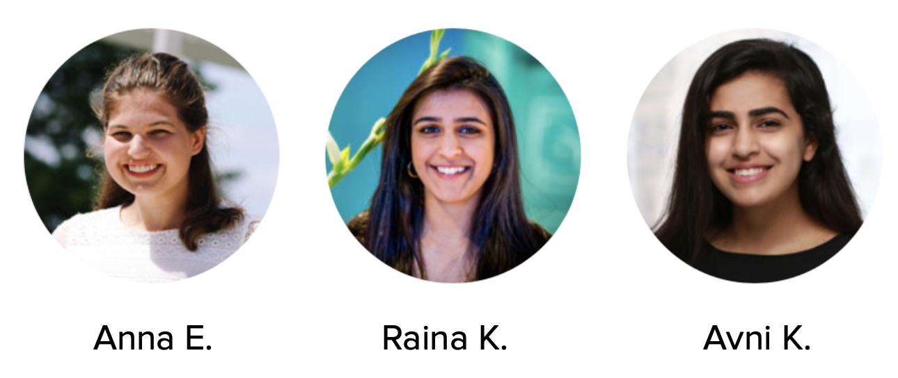

# VALUE PROPOSITION

To streamline political information and empower young voters to shape their futures.

# MISSION STATEMENT

Strengthening democracy.

# PROBLEM/SOLUTION OVERVIEW

# Young voters typically don’t know which politicians best aligns with their views, or what their views really are. As a result, they tend to follow the views of their parents or friends.

# 

# Our solution is to provide an interface where young voters can learn more about voter issues and assess which are most important to them, then match with a candidate that will best represent them for upcoming voting cycles.

# CONCEPT SKETCHES

# 

# SELECTED TWO DESIGNS

1. Dashboard of choices

# 

|  |  |
| --- | --- |
| **Pros** | **Cons** |
| Easy to navigate | Potential for information overload |
| Consolidates information from multiple sources well | Not as fun/appealing to Gen Z |
| A lot of relevant information | Users need to manually change preferences |
| Organized by time frame |  |
| Integration with social media (Twitter) |  |

1. Policy Swiping

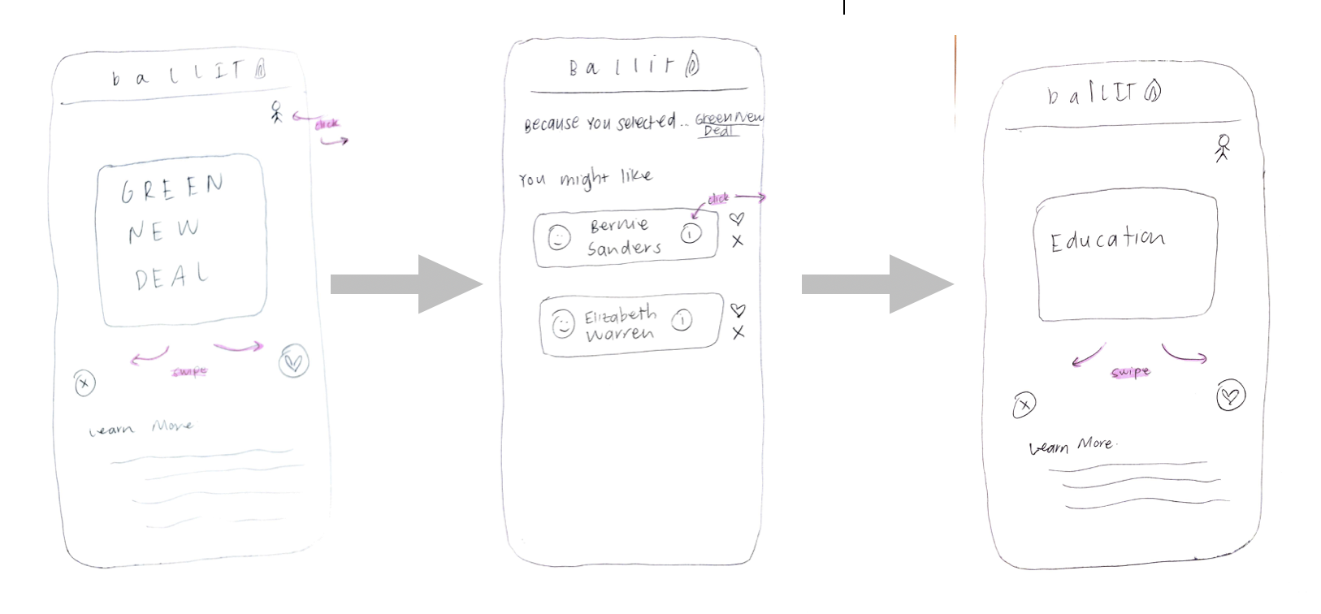

|  |  |
| --- | --- |
| **Pros** | **Cons** |
| Swiping is fun for Gen Z users | Could be too simple |
| Preferences start with important politics rather than candidates | Lacks more than just the swiping feature |
| No single conclusion at the end | Generality may not favor all sides of political spectrum |
| Clean & simple | Not particularly novel idea |
| Simultaneous policy & candidate education | Not conducive to continuous use |

# Final Selected Design:

We ultimately decided to use aspects of both designs and thought they complemented each other well. We maintained the “dashboard” as the overall layout of the application, but still allowed users to “swipe” as a means to inform them about specific policies.

The “policy swiping” design appealed to our target audience, and brought a playful element to a usually tiresome activity. However, the primary problem was that it felt “single-use”; users would have no incentive to return to the platform if they had already swiped on a policy. The overall design also did not support updating profiles with current events and new information. Swiping by its nature is binary, and could have forced users into a false choice.

The “dashboard” was easy to use and provided streamlined, relevant information. The issues were the potential for information overload and the resemblance to more traditional political media platforms. We determined that in the case of politics, more information is often better. We want our users to be as informed as possible about the policies and candidates they support and we believe that the “dashboard” layout is not overwhelming in the way that the New York Times front page or Twitter can be. We also realized that combining the “swiping” with the “dashboard” would allow us to still target Gen Z strongly .

We also added a home page with trending news stories, because we realized that keeping up with current political events was a vital feature for any political information tool. We realized that current events are often what inform a user’s policy preferences and that it would be irresponsible to not educate users about those events before asking them to organize their political opinions.

# 

# 

# 

# 

# 

# 

# 

# 

# 

# 

# TASK STORYBOARDS

# (Simple) Choosing a policy

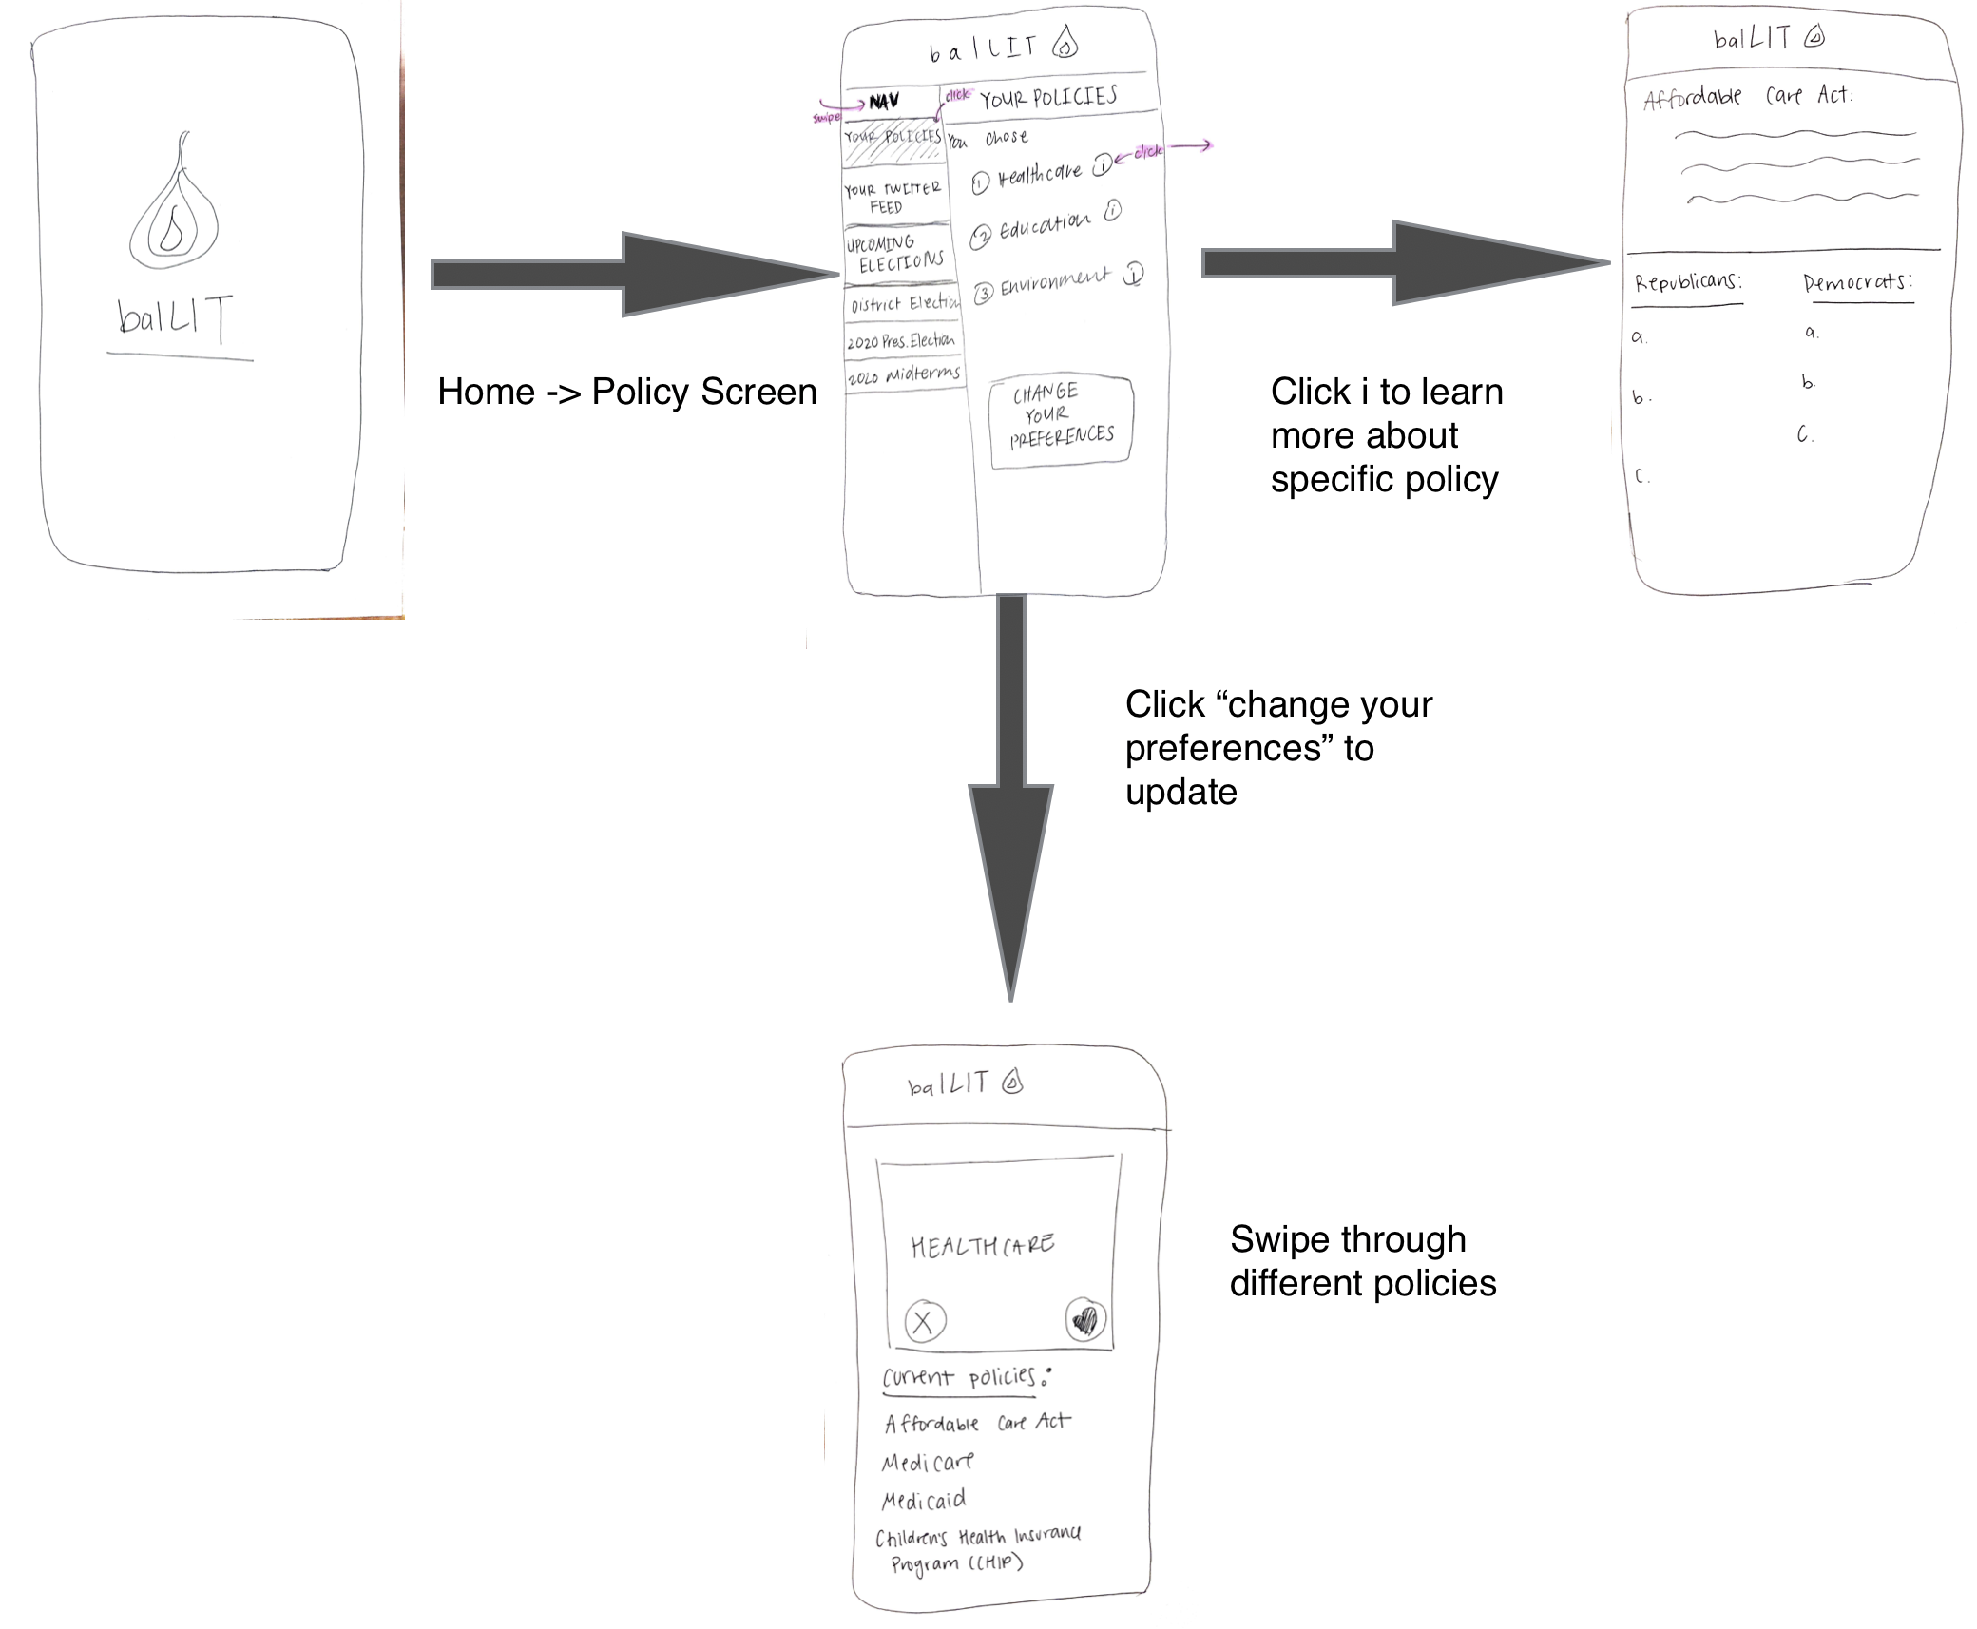

# :

# 

# 

# (Moderate) Learning who your candidates are

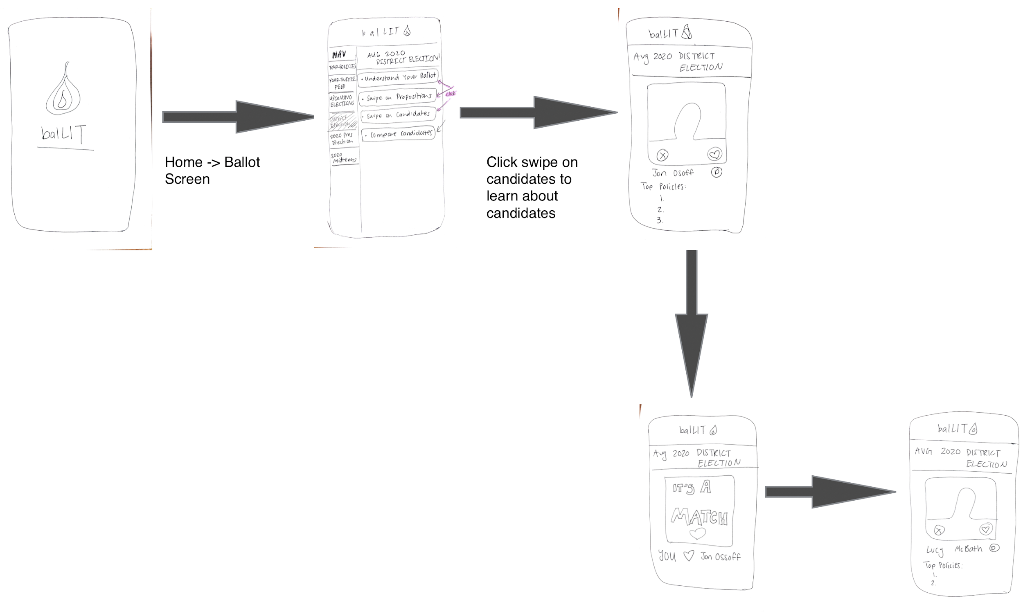

# (Complex) Comparing candidates

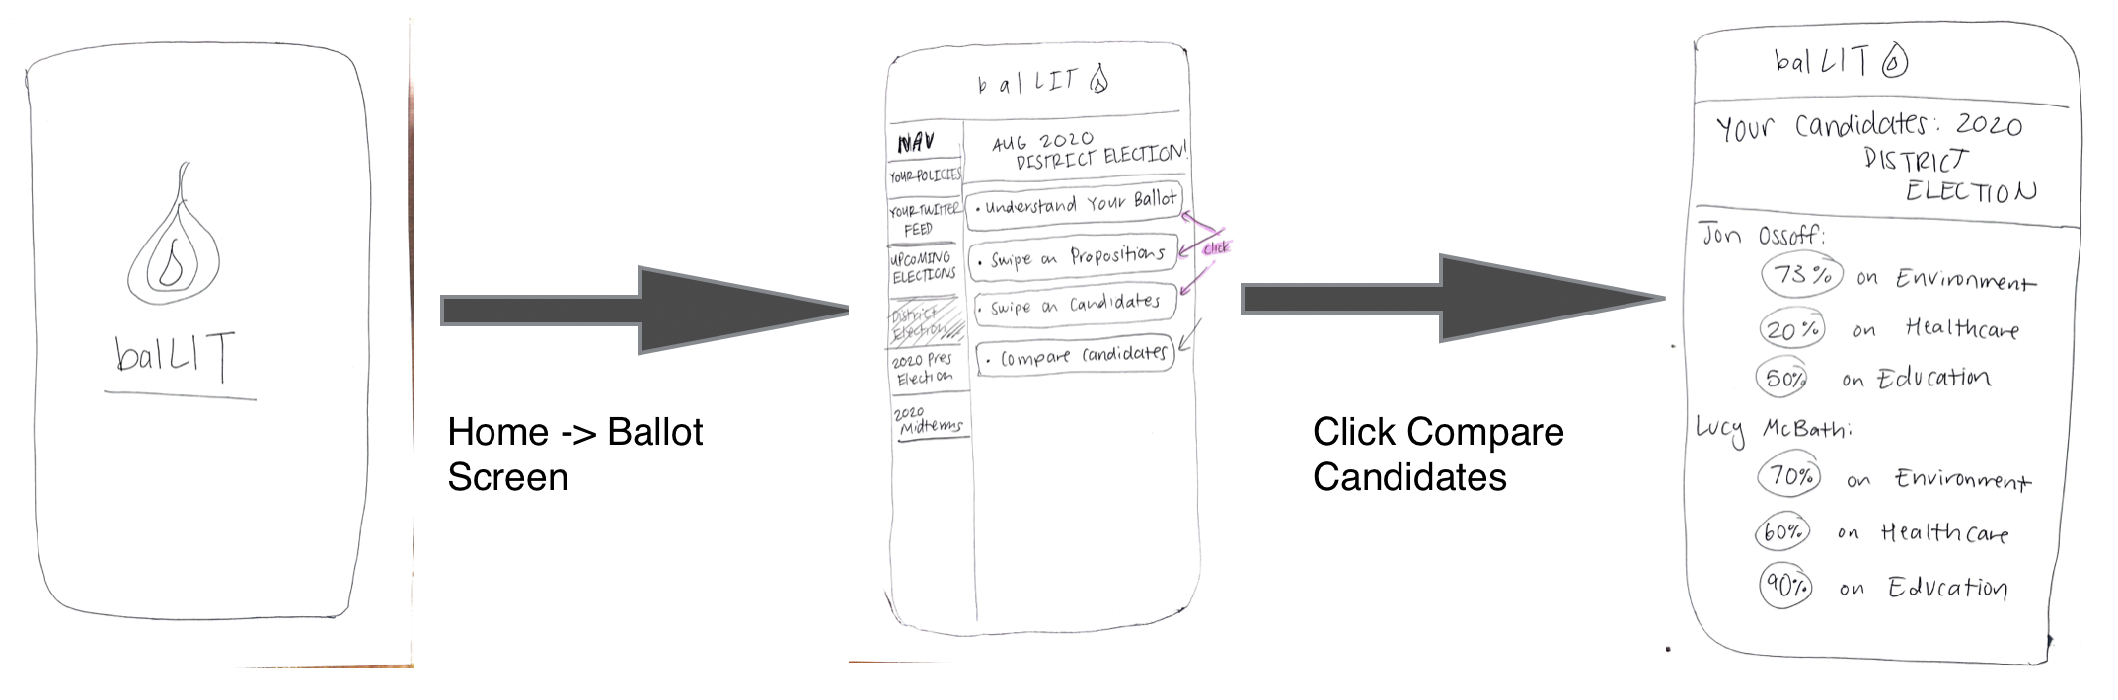

# 

# LO-FIDELITY PROTOTYPE

# 



# 

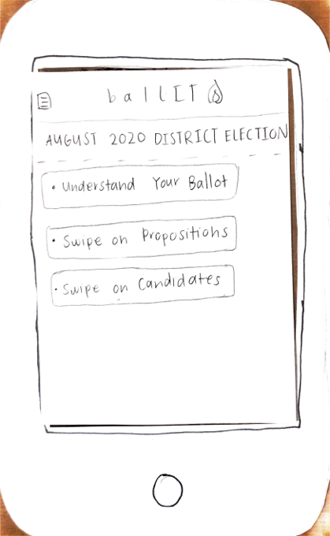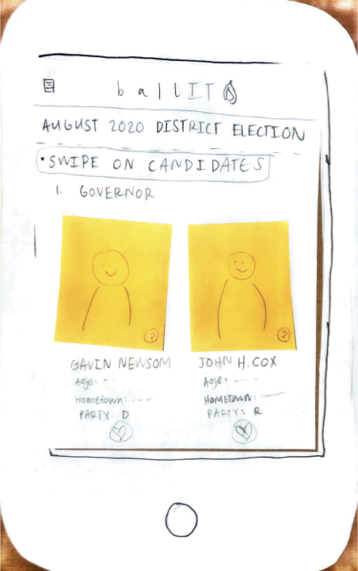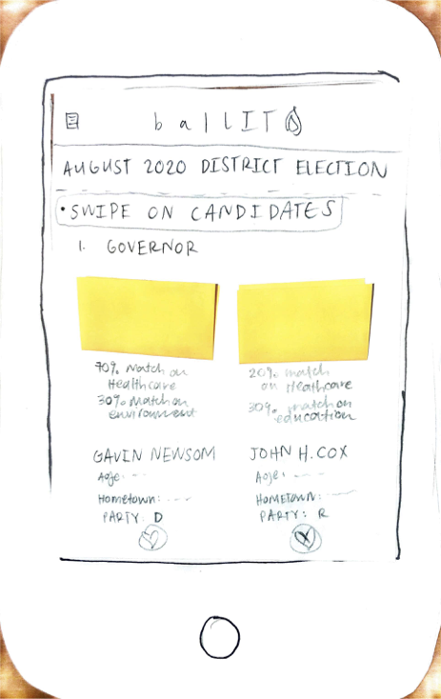



# 

# 

# 

# 

# For our low-fi prototype, we created a paper prototype on top of a foam phone mock-up. We drew each screen on a sheet of paper and used post-it notes to denote places users could “click” to get more information. As you can see above there are four key aspects of our prototype:

1. **Home screen/news feed**: The home page welcomes the user back and provides a simple digest of top news stories. This helps users stay up-to-date simply.

|  |
| --- |
|  |

1. **Choosing policies**: This has users “swipe” to learn more about certain policy areas and either “swipe right” to add a policy to their profile, or “swipe left” to reject a policy from their profile. Users can click into each policy area to get more information such as recent bills, as well as Republican vs. Democrat approaches to the issue.

|  |
| --- |
|  |

1. **Learning about upcoming elections**: These pages has users learn more about elections, from what elections are coming up to who is running in them to what propositions are being voted on. This was intended to be a simple, consolidated page for users to get all the basic information they needed.

|  |
| --- |
|  |

1. **Deciding between candidates**: One of the primary goals of our platform is to help young voters decide who to vote for. Since we already have data on what policies our user supports and how important each issue area is to them, we have the information we need to reasonably determine what candidates they are most likely to agree with. These pages are designed to streamline the decision process and present the user with easy-to-read, relevant data. Users can see competing candidate profiles, and click to see how much they agree with each candidate on certain issue areas (i.e. 70% on environmental issues). They can then swipe to select the candidate that they intend to vote for.

|  |
| --- |
|  |

|  |  |
| --- | --- |
| **Interface Element** | **Functionality** |
| Home Screen / News Feed | See recent news related to your selected policy interests and candidates. Click on any headline to see read more. |
| Policy Screen | Learn more about policies you’ve selected. Click change my preferences to swipe between policies. |
| Policy Swiping | Swipe and learn more about policies. Make one by one choices about policies that are interesting with a swiping model. |
| Discover Ballot Screen | Learn about candidates who are listed on your upcoming ballot. Read about their policy proposals. |
| Choosing Candidates | Swipe to choose a candidate. Be told who you are likely to agree with. |

# 

# EXPERIMENTAL METHODS

Our first two participants were selected from Stanford by blasting an email through a friend’s dorm. From the responses to the email blast, we selected two participants who none of us knew and had no prior knowledge of our project. These two participants we then interviewed in a silent room where all three group members were present.

Our final participant is a high school senior at Palo Alto High School. We found them by going to Town and Country shopping center at the end of the high school day, and speaking to a few different students. From there, since we had met our participant in Town and Country, it would be difficult to find a quiet place to conduct our interview, we just did the testing on a bench in the shopping center. Although this is not the ideal testing environment, we found that we still got effective results from our testing session.

For each of our participants, we had them perform the three tasks outlined above. We gave them minor guidelines on the features that the interface is able to perform, but did not specifically tell them how to execute the tasks. In these scenarios, Anna acted as the computer, Raina acted as the facilitator, and Avni acted as the observer. We stuck with the same roles through every trial run to ensure as similar testing conditions as possible through each participant.

Our primary assessment through the testing process has been successful completion of each individual task. If there had not been successful completion of the task, then we can reason that there would be a gross inadequacy in the implementation of the interface to aid with completing that task. On top of that, we also considered user satisfaction with the process of executing that particular task. We wanted to ensure that participants were satisfied and entertained throughout the process of each task. This was gathered through verbal feedback from our participants. Our final test measure was number of errors made while executing the task and how intuitive it was to execute the task. We wanted to see if the interface was learnable, if a participant would make errors and learn from them, or never make mistakes in the first place.

One last minor aspect we considered was whether the user would want to explore the interface. This was difficult to facilitate since it was so low-fi, but was still valuable with understanding how appealing the interface was to users.

# EXPERIMENTAL RESULTS

Overall, we found that all of our participants were able to successfully complete all of our tasks, however, we found that all participants made mistakes on the way to the successful completion of the tasks. Participant A found that some paths were a little unintuitive while trying to complete Task one, and got confused among the multiple options on the policy screen. Participant A also noted that they wish that there had been more differentiation between different specific policies, as this prototype only considered broad policy areas. Both participants A and C noted that they really enjoyed the process of swiping.

While performing task two, participant B noted that they were a little disappointed that there was no integration with chosen policies when discovering candidates, and then when performing task three, noted that task two and three are very similar. Both participants A and C also noted that they preferred the personalization of the choosing candidates task.

Overall, all participants seemed to enjoy the interface and the tasks that they got to perform. They all noted that it would be an interesting product to use and encourage Gen Z to get involved with politics.

# DISCUSSION

We have gathered a lot of valuable information throughout our testing process. Since all participants were able to successfully complete all three tasks, we are pretty confident in the general design and idea of the interface, and will be continuing on with improving the work that we have done.

However, all participants brought up valid points where the interface could be improved. Our most important feedback was the melding of task two and three. All participants preferred the third task to the second task, as it included the personalization of the policies that the user has selected as important. This shows that there needs to be a more dedicated space for task two, or reformulation of the moderate level difficulty entirely.

Our other major change that needs to be made for the next revision is changing the process of swiping through policies. This has shown that users are more interested in the different forms that one policy can take on, than just the policy in general. In future revisions we will ensure that participants will get to swipe between specific policies, such as The Green New Deal directly.

One important piece of feedback received was the appreciation for the integration with the Twitter feeds of candidates that the participants liked. Since this was such a successful feature, we can consider expanding this with other social media feeds of the candidates. This shows that users are interested in what is continuously happening with their favorite candidates, and want that continuous update.

Overall, this interface was highly successful with our participants. We will now be able to go into more detail with our next iteration of prototypes. We have learned that our users want more detail and more room to dig deep into the areas of politics that interest them.

**APPENDIX**

# Script:

Hi! Thank you for taking part in our study. We’re students taking a human computer interaction class at Stanford, and our project is BalLIT!, a form of political education for Generation Z voters. As you test our app, we’d like you to participate in the “talk aloud” process, where you say everything you’re thinking as you perform actions.

For this scenario, you have just opened the app for the first time and are starting with the navigation page. We have a couple tasks we’d like you to complete, but let us know any of your thoughts as we proceed!

To start off, your first task is:

**Moderate:** Choose which policies matter to you the most. You can find more information about each policy, if you wish.

After you complete this, you are free to review the policies that you chose, and edit them.

Now, using this information, let’s look at the upcoming local election.

**Simple:** For this election, you are free to “Understand your Ballot.” This will show you a blurb of the candidates running for each position for this election and blurbs for each proposition you will have to vote on.

Once you understand your ballot, we are ready to choose candidates.

**Complex:** Head over to “Swipe on Candidates.” Here we have our first choice to make. You can see a smaller blurb of what they represent again, and also a matching metric to see how well they align with your views, based on your earlier swiping on the policies.

Awesome! Thank you so much for participating. We hope this made this fictional election easier to navigate. Feel free to contact us with any questions!

Red text denotes errors (4 = usability catastrophe), green text denotes successes (0 = no problem)

##### **Participant A**

|  |  |
| --- | --- |
| Incident | Severity Rating |
| Unintuitive how to navigate policy screen | 2 |
| Wishes that there had been more differentiation between policies | 2 |
| Swiping is fun | 0 |
| Felt that tasks two and three were too similar | 2 |
| Twitter integration is interesting | 0 |
| Design is fairly intuitive - didn’t make too many mistakes | 0 |
| Now bored with task two as task three was more interesting and personalized | 4 |

##### **Participant B**

|  |  |
| --- | --- |
| Incident | Severity Rating |
| “I wish that there had been more policy integration when discovering candidates” | 3 |
| Information overload with dashboard - but did not make any errors | 2 |
| Thought policy choosing was too non-continuous | 2 |
| Enjoyable to use | 0 |
| Liked the integration with personal ballot | 0 |
| back button intuitive | 0 |

##### **Participant C**

|  |  |
| --- | --- |
| Incident | Severity Rating |
| Liked the idea of swiping immediately | 0 |
| Liked the personalization of candidates you agree with | 0 |
| Made extremely few mistakes | 1 |
| Task two is now redundant | 3 |
| Clicked in a few incorrect places - “labels seem similar” | 3 |